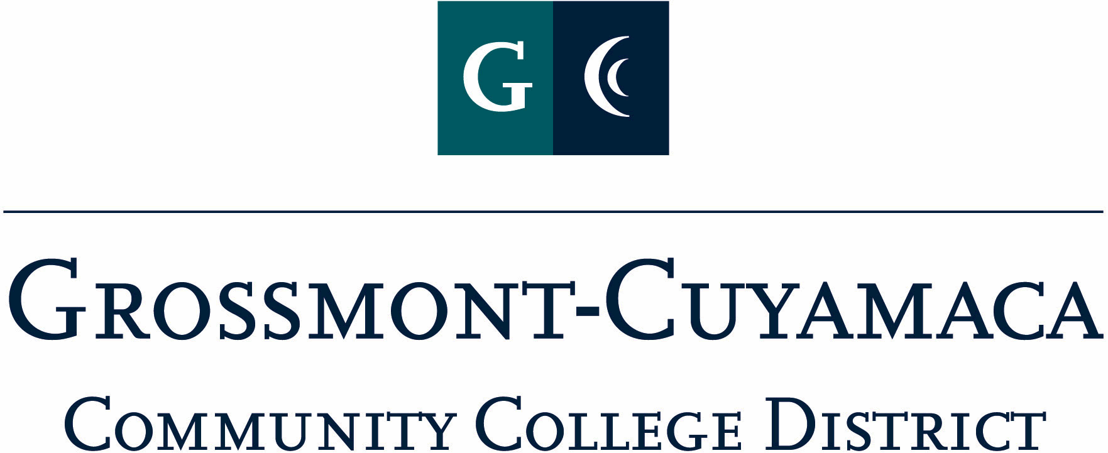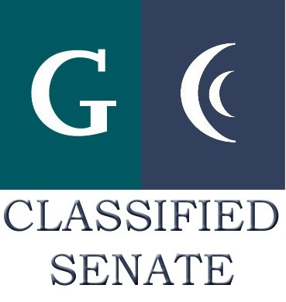
D R A F T
CLASSIFIED SENATE
EXECUTIVE BOARD MEETING
May 4, 2010 – Meeting Minutes

Members Present: Debi Miller, Patricia Bailey, Kimberly Gioscia, Maria Briney, Angela Johnson, Jacqueline Osborne, Pat Murray, Karen McCoy, Rocky Rose
Members Absent: Tasa Campos, Scott Howell, Karen Ostegard
Members Excused: Paula Tillery, Maggie Gonzales, Avelina Wilder, Monica Farris, Wendy Corbin, Yvette Macy

1. Welcome and Call to Order

The meeting was called to order at 12:10p.

2. Approval of Minutes from April 13, 2010

Quorum was not met, the minutes will be disseminated to the group via e-mail, and a record kep of the approval.

3. Communication

VP Reports

District: Wendy Corbin was unavailable for the meeting. The district board members that were present did not bring anything forward.

Grossmont: Pat Murray reported on the following:
- The Grossmont College Accreditation Mid-term Report has been placed on the college website for viewing and comments. She asked the classified members to look to Recommendation 7 as it pertains to our membership and a comment section is available.
- Reminded the group of the upcoming Planning & Resource Council open meeting on May 12 at 3:00 at Griffin Gate. This is an effort by the college to offer an opportunity for the classified to be informed about the process for budget matters. She has not received the February meetings minutes yet to forward to the group.
- Committee appointments are going well and she has found classified representation on the Room Utilization, Food Advisor and the new Director position.
- Some of the college credit cards have been hacked into, please look at your statements carefully.
- She announced she is on the Commencement Committee and classified are participating with the event.

Cuyamaca: Maggie Gonzales was unavailable for the meeting. Debi Miller, President, reported out that the Cuyamaca College Accreditation Mid-term Report has gone through its shared governance approval process, and is now being reviewed for evidence links.

President’s Report: Debi Miller reported on the following:
- Southeast Region Leaders Retreat was held on April 23rd at Saddleback College and Wendy Corbin, Karen McCoy (representing Pat Murray), Maggie Gonzales and myself were invited. Unfortunately, Maggie was not able to attend do to a medical situation. The Retreat was organized to include all the Presidents and Vice Presidents of the Southeast Region Classified Senates. There were six colleges and 3 districts represented. The group decided to hold these Retreats on a semi-annual basis in January and August. If one of our VPs or President can’t make it then one of the Executive Board members will be asked to represent. As the event progresses in time, other Board members will be asked to attend as well.
- CS Retreat Date – we are currently holding 8/5 and 8/6 for our annual retreat due to the change in work schedule. A proposal was sent to the Chancellor explaining 3 possible scenarios for accommodating the release time and the 4 10 hour day summer schedule.
- CS Retreat Topics – Debi went over the Retreat topics that had surfaced over the last year at the monthly meetings and solicited the group to send her any other topics for consideration. Currently the list includes: Developing Core Values/Ethics Statement, CLI 2011 (possible fundraiser), CSAD – Chair Assignments and Budget.
- Chancellor Classified Senate Award – Debi Miller would like to include a district rep on the review committee, so all locations are represented. She will ask Wendy to send out a call for committee participation to see if anyone might be interested.
- She informed the group that there would be no elections this year due to the 2-year term assignment, but would be addressed at next year’s Annual Organizational Meeting.

Treasurer Report: Debi Miller reported that according to IFAS the total in the Trust account is $3,176.35. Paula Tillery informed her before the meeting that there would be $60 in Cookbooks added along with a $500 donation from AFT and $150 from CSEA, bringing it to a total of $3,886.35.

Debi added that the CSAD 2010 Budget has not been reconciled yet and presently has a carryover amount of $2,725.54. Monica Farris is hoping to reconcile in time for the next meeting.

4. Continuing Business

Mother Goose Parade: Yvette Macy and Wendy Corbin were to report back to the group on this event, but were unable to attend. Yvette had sent some information via e-mail and Debi Miller summarized that they are intending on submitting the proposal to the Chancellor by 6/1 for district buy-in and estimate that the float costs range from $700-$1500. She suggested that a 6-person committee be established and that she and Wendy would take leadership roles in this event. This agenda item will be carried over to the June meeting when Yvette and Wendy are available to explain in more detail and solicit volunteers for the committee.

5. Fundraising Activities:
6. Governance:
7. New Business:

BBQ Fundraiser: Yvette Macy requested that this item be placed on the agenda for discussion. She was unable to attend the meeting, so it will be carried over to the June meeting.

Pat Murray added that she has spoken to Cari Plyley, President Emeritus at 4CS, customarily at the CLI event they highlight the award winners from each of the college. Debi Miller will be highlighted as well for receiving her recent award from 4CS for her help in organizing the Southeast Region Leaders Retreat.

The meeting adjourned at 12:37p.

